****cv 

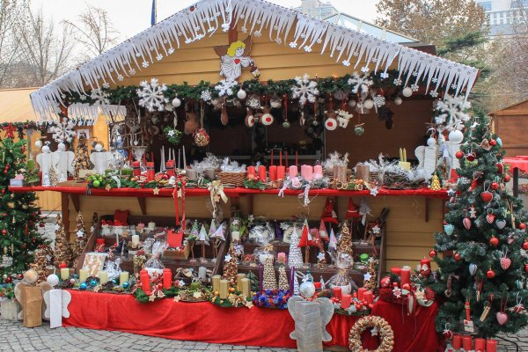

**CHRISTMAS BAZAR**

**3rd Junior High School**

**At 23/12/22 in the City Center**

**Entrance: For Free**

**FOODS-CRAFTS-GIFTS-CHRISTMAS DECORS-SURPRISES FROM SANTA CLAUS**

**Names:**

**Kalliopi Vidoura**

**Aristidis Avramidis**

**Stella Toka**

**Zoi Afedoulidi**

**Lokman Arif**