**THE EIFEL TOWER**

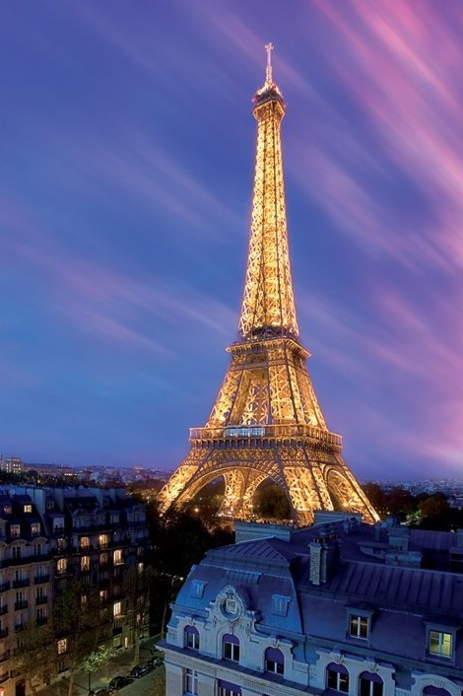The Eiffel Tower is located in the [Champ de Mars](https://en.wikipedia.org/wiki/Champ_de_Mars) in [Paris](https://en.wikipedia.org/wiki/Paris), France. The tower is 330 metres (1,083 ft) tall. and the [tallest structure in Paris](https://en.wikipedia.org/wiki/List_of_tallest_buildings_and_structures_in_the_Paris_region). The tower has three levels for visitors, with restaurants on the first and second levels the highest [observation deck](https://en.wikipedia.org/wiki/Observation_deck) accessible to the public in the [European Union](https://en.wikipedia.org/wiki/European_Union).

**HISTORY**

The Eiffel Tower was constructed in 1889, when Paris hosted an Exposition Universelle (World’s Fair). Originally intended as a temporary exhibit, the Eiffel Tower was almost torn down and scrapped in 1909. City officials opted to save it after recognizing its value as a radiotelegraph station.

**TOURISM VISIT**

* **TRANSPORT** The Eifel Tower is open to visit every

The nearest [Paris Metro](https://en.wikipedia.org/wiki/Paris_M%C3%A9tro) station is day from 9:30 am to 10:30. Tickets cost

[Bir-Hakeim](https://en.wikipedia.org/wiki/Bir-Hakeim_(Paris_M%C3%A9tro)) and the nearest [RER](https://en.wikipedia.org/wiki/R%C3%A9seau_Express_R%C3%A9gional) station is from 10€ up to 25€ for adults while there

Champ de Mars-Tour Eiffel. The tower discounts for children. Tickets for kids

itself is located at the intersection of the under 4 years old are free. For more

quai Branly and the Pont d'Iéna. information you can visit: https://www.

toureiffel.paris/en/news/events/new-

eiffel-tower-rates

* 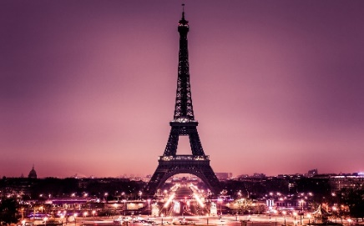**RESTAURANT**

The tower has two restaurants: Le 58 Tour

Eiffel on the first level, and [Le Jules Verne](https://en.wikipedia.org/wiki/Le_Jules_Verne),

a [gourmet](https://en.wikipedia.org/wiki/Gourmet) restaurant with its own lift on

the second level. This restaurant has one

star in the [Michelin Red Guide](https://en.wikipedia.org/wiki/Michelin_Guide).

*Galani Penelope-Georgia Amorianou Natalia-Kyriaki B1*