**PALACE OF VERSAILLES**

Εικόνα που περιέχει χάρτης

Περιγραφή που δημιουργήθηκε αυτόματα

1.The palace of Versailles is located a few kilometers outside of Paris in the city of Versailles. Today it is one of the world monuments UNNESVO heritage site.

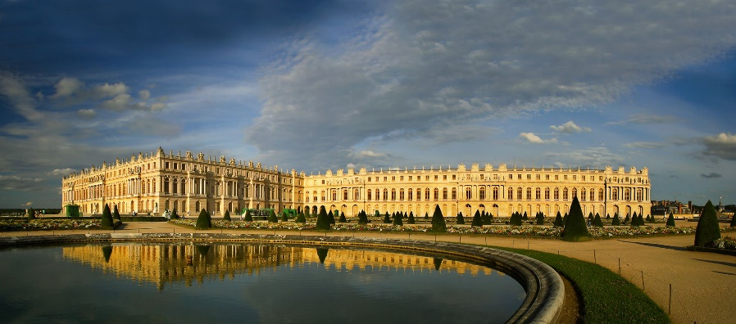

2.Versailles was until 1660 a small palace used as a hunting refuge, after 1660 King Louis I D decided to expand it. The palace consists of three parts mainly where the royal family lived and two other wings on the right and left where the nobles, the clergy and the ministers lived. Another 3 buildings were built to house the kitchen staff, the hundreds of horses along with their carriages and all the rest of the equipment.

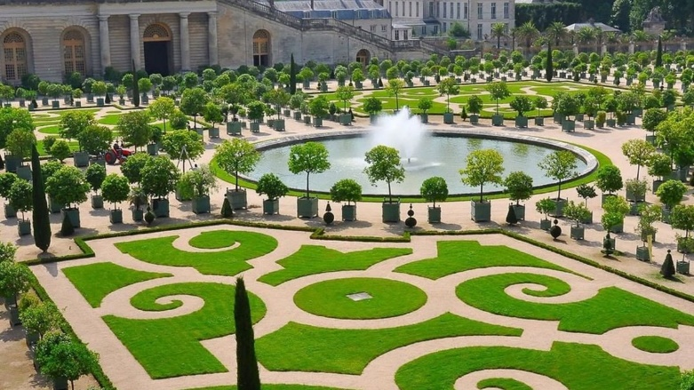

**PALACE OF VERSAILLES**

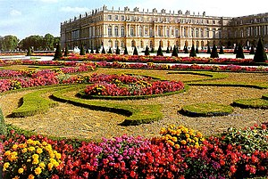

3.The palace of Versailles is known for its huge gardens along with many fountains and statues. Its area reaches 800 hectares and its photo coverage is the work of the royal gardener Andre Le Notre. Greek mythology is imprinted on the fountains and statues as well as on the inside of the palace. Like the palace the gardens are intended to honor the king and his country. The great rivers of France are represented as statues and the fountain of Apollo is more majestic of Versailles.

The palace of Versailles cost a total of 2.6 billion. That was also an indirect reason for the French Revolution as at the end of the reign of the Sun kingdom the coffers of the state were literally empty. With frequent renovations, its cost reached 250 billion. It is one of the most expensive buildings in the world and every year it is visited by tourists from all ove the world to see and admire it.

**PALACE OF VERSAILLES THE END.**