FAMOUS WOMEN’S BIOGRAPHIES
ST1 CLASS OF 18TH PRIMARY SCHOOL OF EVOSMOS

Marie Curie - Biography by Chris-Aggelos Koukiotis
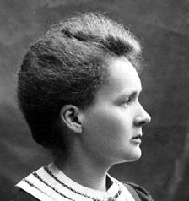
Marie Curie was born on November 7th 1867 in Warsaw and her real name was Marie Sklodowska.
Marie Curie source: Nobel Foundation
She was the daughter of a secondary-school teacher. She received a general education in local schools and some scientific training from her father. She became involved in a students’ revolutionary organization.
After that, in 1891, she went to Paris to continue her studies at the Sorbonne where she obtained Licentiateships in Physics and the Mathematical Sciences. She met Pierre Curie, Professor in the School of Physics in 1894 and in the following year they were married. Later, she succeeded her husband as Head of the Physics Laboratory at the Sorbonne, gained her Doctor of Science degree in 1903, and following the tragic death of Pierre Curie in 1906, she took his place as Professor of General Physics in the Faculty of Sciences, the first time a woman had held this position. She was also appointed Director of the Curie Laboratory in the Radium Institute of the University of Paris, founded in 1914.
Curie throughout her life actively promoted the use of radium to alleviate suffering and during World War I, assisted by her daughter, Irene, she personally devoted herself to this remedial work. She retained her enthusiasm for science throughout her life and did much to establish a radioactivity laboratory in her native city – in 1929 President Hoover of the United States presented her with a gift of $50,000, donated by American friends of science, to purchase radium for use in the laboratory in Warsaw.
Curie’s work is reflected in the numerous awards bestowed on her. She received many honorary science, medicine and law degrees and honorary memberships of learned societies throughout the world.
Finally she died in Savoy, France, after a short illness, on July 4th, 1934.

Empress Wu Zetian – Biography by Aggelos Atmatzidis
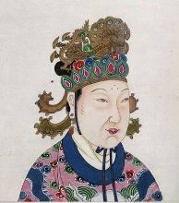
Empress Wu was born on February 17,624 in Lizhou, China.
She grew up in a wealthy aristocratic family and her father was a high ranking minister in the government. Unlike many girls of her time, Wu was given a good education. She was taught to read, write, and to play music. Wu was an intelligent and ambitious girl who learned all she could about politics and how the government worked.
When Wu was fourteen she moved into the imperial palace to serve the Emperor Taizong. She continued her education at the palace until the emperor died in 649.
When the emperor died she was sent to a convent to become a nun for the rest of her life. But she had other plans so she became romantic with the new emperor, Emperor Gaozong, and soon found herself back at the imperial palace as consort (like a second wife) to the emperor.
Back at the palace, Wu began to gain influence over the emperor. She became one of his favorite wives. The emperor’s main wife, Empress Wang, became jealous and the two women became bitter rivals. When Wu’s daughter died, she hatched a plan against the Empress. She told the emperor that Empress Wang had killed her daughter out of jealousy. The emperor believed her and had Empress Wang arrested. He then promoted Wu to Empress. Over the next several years, Wu established herself as a significant power behind the throne. She built up strong allies in the government and eliminated rivals. When the emperor became sick in 660, she began to rule through him.
In 683, Emperor Gaozong died and Wu’s son became emperor. Wu became regent (like a temporary ruler) while her son was still young. Although she didn’t yet have the title of emperor, she had all the power. In 690, Wu had her son step down as emperor. She then declared a new dynasty, the Zhou Dynasty, and officially took the title of emperor. She was the first and only woman to become emperor of China.
During her reign, Empress Wu expanded the borders of China by conquering new lands in Korea and Central Asia. She also helped to improve the lives of the peasants by lowering taxes, building new public works, and improving farming techniques.
Empress Wu died in 705. Her son, Emperor Zhongzong, took over as emperor and reestablished the Tang Dynasty.
Queen Elizabeth II – Biography by Konstantinos Ampelidis
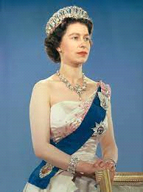
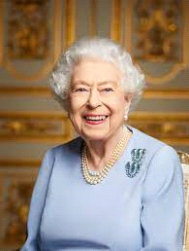
First of all Queen Elizabeth was born in Mayfair, London in 1926. As the child of a younger son of King George V, the young Elizabeth had little prospect of acceding to the throne until her uncle, Edward VIII (afterward duke of Windsor), abdicated in her father’s favour on December 11, 1936, at which time her father became King George VI and she became heir presumptive also she was home-schooled by their governess Marion Crawford. Early in 1947 Princess Elizabeth went with the king and queen to South Africa. After her return there was an announcement of her betrothal to her distant cousin Lieutenant Philip Mountbatten of the Royal Navy, formerly Prince Philip of Greece and Denmark. The marriage took place in Westminster Abbey on November 20, 1947. In the summer of 1951 the health of King George VI entered into a serious decline, and Princess Elizabeth represented him at the Trooping the Colour and on various other state occasions. On October 7 she and her husband set out on a highly successful tour of Canada and Washington, D.C. After Christmas in England she and the duke set out in January 1952 for a tour of Australia and New Zealand, but en route, at Sagana, Kenya, news reached them of the king’s death on February 6, 1952. Elizabeth, now queen, at once flew back to England. The first three months of her reign, the period of full mourning for her father, were passed in comparative seclusion. But in the summer, after she had moved from Clarence House to Buckingham Palace, she undertook the routine duties of the sovereign and carried out her first state opening of Parliament on November 4, 1952. Her coronation was held at Westminster Abbey on June 2, 1953.
Finally, Queen Elizabeth II died of old age. The late British monarch died at 3:10 p.m. UK time (10:10 a.m. ET) on September 8 at Balmoral Castle in Ballater, Scotland. The cause of death is listed as old age.

Hellen Keller – Biography by Konstantinos Rimpas
Helen Keller was born in June 27, 1880 in Tuscumbia, Alabama. and she died in June 1, 1968 in Arcan Ridge, Easton, Connecticut. She was an activist and she was best known for accomplishing much despite being both deaf and blind.
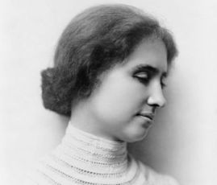
At first, she was a happy healthy baby. Her father, Arthur, worked for a newspaper while her mother, Kate, took care of the home and baby Helen. She grew up on her family's large farm called Ivy Green. She enjoyed the animals including the horses, dogs, and chickens.
When Helen was around one and a half years old she became very sick. She had a high fever and a bad headache for several days. Although Helen survived, her parents soon realized that she had lost both her sight and her hearing. She tried to communicate with the people around her. She had special motions she would use to indicate that she wanted her mom or her dad. However, she would also get frustrated. She realized that she was different and it was extremely difficult to let others know what she needed. She would sometimes throw tantrums, kicking and hitting other people in anger.
Soon Helen's parents realized that she needed some special help. They contacted the Perkins Institute for the Blind in Boston. The director suggested a former student named Annie Sullivan. Annie had been blind, but had her eyesight restored by surgery. Perhaps her unique experience would allow her to help Helen. Annie came to work with Helen on March 3, 1887 and would be her helper and companion for the next 50 years.
Annie began to teach Helen words. She would press the letters of words in to Helen's hand. For example, she would put a doll in one of Helen's hands and then press the letters of the word D-O-L-L into the other hand. She taught Helen a number of words. Helen would repeat the words into Annie's hand. However, Helen still didn't understand that the hand signs had meaning. Then one day Annie put Helen's hand into water coming from a pump. Then she spelled out water into Helen's other hand. Something clicked. Helen finally understood what Annie was doing. An entire new world opened up for Helen. She learned a number of new words that day. In many ways it was one of the happiest days of her life.
Next Annie taught Helen how to read. Helen must have been very bright and Annie an amazing teacher, because soon Helen could read entire books in Braille. Braille is a special reading system where the letters are made out of little bumps on a page. Imagine trying to learn how to read if you couldn't see or hear. It's truly amazing what Helen and Annie were able to accomplish. At the age of ten Helen could read and use a typewriter.
After that Helen Keller learned how to talk from Sarah Fuller. Sarah was a teacher for the deaf. By resting her hand on Sarah's lips, Helen learned how to feel sound vibrations and how the lips moved to make sounds. She started off learning a few letters and sounds. Then she advanced to words and, finally, sentences. Helen was so happy that she could say words.
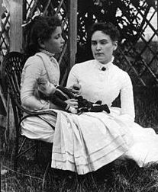
At sixteen years old Helen attended Radcliffe College for women in Massachusetts. Annie attended school with her and helped to sign the lectures into Helen's hand. Helen graduated from Radcliffe in 1904 with honors.
During college Helen began to write about her experiences being deaf and blind. She first wrote a number of articles for a magazine called the Ladies' Home Journal. These articles were later published together in a book called The Story of My Life. A few years later, in 1908, she published another book called The World I Live In.
Helen Keller with Anne Sallivan in July 1888 from the New England Historic Genealogical Society
As Helen grew older she wanted to help other people like herself. She wanted to inspire them and give them hope. She joined the American Foundation for the Blind and travelled the country giving speeches and raising money for the foundation. Later, during World War II, she visited with wounded army soldiers encouraging them not to give up. Helen spent much of her life working to raise money and awareness for people with disabilities, especially the deaf and the blind.

Mother Tereza – Biography by Dimitris Kalogeridis
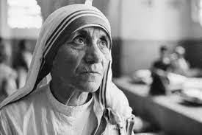
Mother Teresa, also known as Saint Teresa of Calcutta, was a Roman Catholic nun who devoted her life to helping the poor and needy. She was born in Skopje, now the capital of North Macedonia, on August 26, 1910, and was named Agnes Gonxha Bojaxhiu. She was the youngest of three children born to Albanian parents. Her family was deeply religious, and her parents instilled in her a strong faith and a sense of compassion for others.
At the age of 18, Agnes left her home to join the Sisters of Loreto, an Irish community of nuns with missions in India. She took the name Sister Mary Teresa and taught at a school in Calcutta (now Kolkata) for almost 20 years. It was during this time that she felt called to leave the convent and work directly with the poor.
In 1948, Mother Teresa founded the Missionaries of Charity, a religious congregation dedicated to serving the poorest of the poor. The congregation began by providing basic medical care and education to the impoverished residents of Calcutta. The group grew rapidly, and soon Mother Teresa and her sisters were providing food, clothing, shelter, and medical care to people all over India and eventually in other parts of the world.
Mother Teresa's selfless work and dedication to the poor earned her international recognition and many awards, including the Nobel Peace Prize in 1979. She used her fame to advocate for the rights of the poor and to draw attention to their suffering. She also inspired countless others to join her in her work, and her congregation now has over 4,500 sisters working in 133 countries.
Mother Teresa's work was not without controversy, however. Some criticized her for the quality of care provided by her organization, while others questioned her motives and the influence of her religious beliefs. Despite these criticisms, Mother Teresa remained steadfast in her mission, and her legacy continues to inspire people all over the world.
In addition to her work with the Missionaries of Charity, Mother Teresa also wrote several books, including "Come Be My Light," a collection of her private letters that revealed her spiritual struggles and doubts. She died on September 5, 1997, at the age of 87. In 2016, she was canonized by the Catholic Church, becoming Saint Teresa of Calcutta.
Mother Teresa's life and work are a testament to the power of selflessness and compassion. She devoted her life to serving others and inspired countless others to do the same. Her legacy continues to inspire people all over the world to work for the betterment of humanity, and her example serves as a reminder that even the smallest acts of kindness can have a profound impact.

Amelia Earhart – Biography by Vaggelis Gioufis
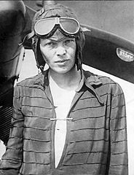
Amelia Earhart was born on July 24, 1897 in Atchison, Kansas and was an American aviation pioneer and writer. Her father, Edwin, was a lawyer who worked for the railroad. She spent a lot of her childhood playing with her younger sister Muriel. Growing up Amelia and her sister had all sorts of adventures. They collected insects and frogs. They liked to play sports including baseball and football. Amelia even learned to shoot a .22 rifle and used it to kill rats in her Dad's barn.
Amelia's first "flight" was when she was just seven years old. With the help of Muriel and her uncle she made a homemade roller coaster. After crashing dramatically she told her sister that it "was just like flying". When Amelia was eleven years old, in 1908, she saw one of the Wright Brothers first airplanes at the Iowa State Fair. She had no interest in flying and didn't think much of the plane at the time. On December 28, 1920 Amelia and her father visited an air show in California. Amelia went on her first plane flight that day. She later said that "I knew I had to fly" as soon as the plane was just a few hundred feet off the ground. Amelia worked hard and, together with some money from her mother, she was able to pay for flying lessons. Eventually she purchased her own plane. A bright yellow airplane she nicknamed the "Canary". She also got her pilot's license and set a new altitude record for female pilots of 14,000 feet.
Amelia Earhart awaits transatlantic flight in 1928 by Wide World Photos
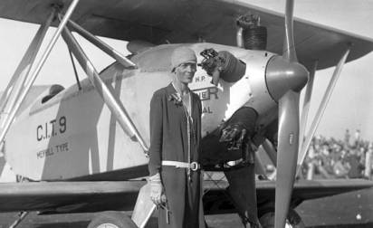
In 1928 Amelia was invited to take part in a historic flight across the Atlantic. Together with pilot Bill Stultz and co-pilot Slim Gordon, Amelia flew across the Atlantic Ocean in the airplane Friendship. Amelia was the navigator on the flight. On June 18, 1928 after twenty one hours of flying, the plane landed in Wales. She was the first woman to make the flight across the Atlantic. Amelia was not satisfied, however. She wanted to make the same trip across the Atlantic, but this time she wanted to pilot the plane and make the flight by herself. On May 20, 1932 she took off from Harbour Grace, Newfoundland aboard a bright red single engine Lockheed Vega airplane. She intended to make the same flight that Charles Lindbergh had made five years before and fly to Paris, France. The flight was very dangerous. There was bad weather, thick clouds, and often her windshield and wings were covered with ice. Fourteen hours later she had crossed the Atlantic Ocean, but had to cut the flight short, landing in a cow pasture in Londonderry, Northern Ireland. Amelia became only the second person after Charles Lindbergh to successfully fly across the Atlantic Ocean solo. She received many awards including becoming the first woman to receive the Distinguished Flying Cross from Congress.
Amelia Earhart from the Los Angeles Daily News
On June 1st 1937 Amelia and Fred Noonan, her navigator, took off from Miami, Florida. They flew a number of flights, eventually getting all the way across Africa and Asia to New Guinea in the South Pacific. On July 2nd they took off from New Guinea to fly to Howland Island in the Pacific Ocean, but they were never seen from again. Finally, she was declared dead on January 5th 1939 at the age of 41.

Frida Khalo – Biography by Elisabeth Elenidou
Frida Kahlo was born on 6th July, 1907 and grew up in the village Coyoana in Mexico.
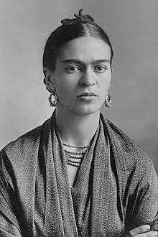
When she was 6 she had an illness (polio). Then one of her legs was smaller than her other leg. 12 years later, she had an accident with a bus and she was left handicapped.
Frida Khalo by Wikipedia
From an early age she loved art. At first she learned that art can express her feelings. She especially painted her real life, portrait and hard times like her accidents and her relationship with her husband Diego Rivera.
She was inspired by Mexicans. She used bright colors and often made small paintings.
Finally on 13th July, 1954 she died because she had an illness at her lungs.

Florence Nightingale – Biography by Sofia Kirimkiridou
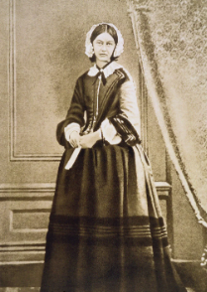
Florence Nightingale was born into a wealthy family in Florence in the Italian province of Tuscany on May 12,1820. She also got her name from there. At the age of 20, she announced to her parents that she would like to become a nurse, but they refused her, telling her that this profession did not suit their social class. When she turned 30 she decided to stay single and study nursing in Kaiserswerth. During the Crimean War she took up the post of superintendent at King's College Hospital.
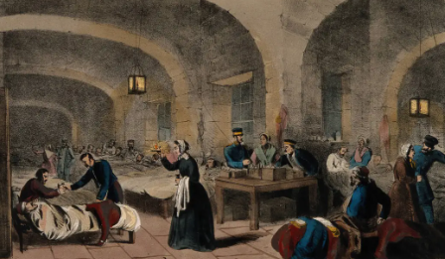
Then she worked in a hospital in Scutari, near Istanbul, which housed 1,500 patients under truly awful conditions. The hospital's mortality rate had reached 42%, because patients with severe cases of epidemics were treated there. Nightingale went down in history moving between patient beds at night holding a lantern and her tireless efforts to relieve the pain of patients earned her the nickname "The Lady with the Lantern". But during the time when they were working in the Crimean War she was known by the nickname "The Lady with the Hammer" because once when she was denied access to a locked pharmacy she, contrary to what was denied access to a locked pharmacy she, contrary to what one would expect from a tender nurse of noble birth, took a hammer and broke the lock.
After the end of the war she returned to England and retired to her private life. She finally died in August 13th 1910.

Princess Diana – Biography by Sofia Tsapada
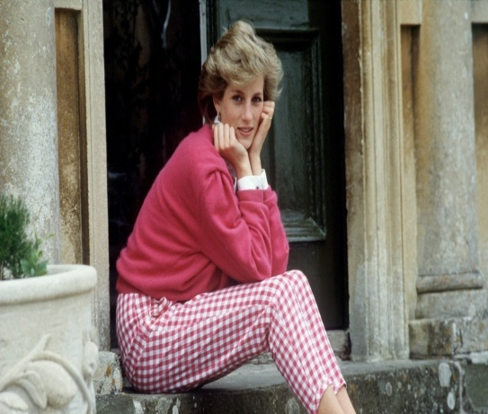
Diana was born on July 1 1961 in Norfolk, England. Her father was John Spencer and her mother was Frances Shand Kydd. She also had to sisters, and a brother. She did not spend much time with her sisters as they were sent to boarding school. That made her relationship with her brother stronger. Diana loved to help others and she was into music and art.
When she turned 18 she moved in an apartment with 3 friends of hers. Her dad was paying for all her expenses but she wanted to work so she took a job as assistance in a kindergarten as she loved kids. She met Prince Charles when she was young but at first, their relationship was secret. When it got published, reporters followed her everywhere.
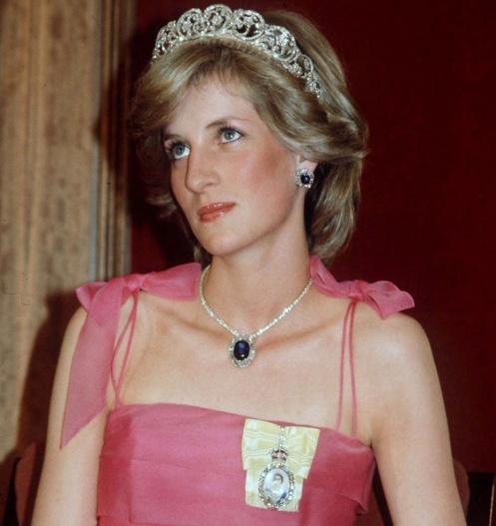
She got married to Prince Charles at the age of 20 and they had a huge wedding at St Paul’s Cathedral in London. Before the wedding, Diana had moved to Buckingham palace to learn everything about being a princess. Almost 750.000.000 people watched the wedding live. After the wedding Diana felt lonely as she was not seeing Prince Charles that much. She gave birth to Prince William in 1982. She was really happy to have a child but it was also hard for her. Two years later she gave birth to Prince Harry.
Diana was also known for her charity work and her love for others. In 1989, she offered treatment and support to AIDS and HIV patients who were suffering. In 1990, she attended the first ever ‘Women Aids & the Future’ conference. Three years later she delivered her own speech on ‘Women & children with AIDS’. In 1992 she became a patron to Contrepoint, a charity that provides housing and support for those who need it all over the U.K.
The relationship between the couple only got worse and worse, so they divorced in 1992. After her divorce, Diana started to visit sick children and helping lots of people. On August 1997, she visited Paris. The car she was in was followed by paparazzi as always and it crashed. Diana finally died that night. Over 2 billion people watched her funeral on TV, as she was loved the most by the public.

